**Intel College Excellence Program   
Project Synopsis**

**“RFID-Based Access Control System”**

|  |  |  |  |
| --- | --- | --- | --- |
| **Team member’s detail** | | | |
| **S. No.** | **Participant Name** | **Mobile No.** | **Email ID** |
| 1 | K. VashistaHemanth | 7801029076 | ***vashistaofficial@gmail.com*** |
| **Faculty(college) mentor detail** | | | |
| **S. No.** | **Mentor Name** | **Mobile No.** | **Email ID** |
| 1 | Dr. Sanjeet K. Sinha | 8555907951 |  |
| **College/University Name** | | | |
| ***Lovely Professional University*** | | | |

**BACKGROUND**

Access control systems that rely on RFID technology have transformed security protocols, providing efficiency and comfort in a range of environments. This is a brief account of their evolution over time:   
  
1. Invention of RFID: Originally developed for aircraft identification during World War II, radio-frequency identification (RFID) technology dates back to this era. But commercial uses of the technology did not begin to appear until the 1970s.  
  
  
2. Early Applications: RFID was first applied in the manufacturing and logistics sectors for monitoring and identifying needs. It was appealing for supply chain optimization and inventory management due to its wireless data transmission capabilities.   
  
3. Entry into Access Control: As computerized systems proliferated in the 1980s and 1990s, RFID began to be incorporated into access control systems. Traditional techniques like keys or swipe cards were superseded by these systems, which

4. Improvements in Frequency: RFID operates at various frequencies, each of which has unique benefits. With differing ranges and data transfer speeds, low-frequency (LF), high-frequency (HF), and ultra-high-frequency (UHF) RFID systems were developed.   
  
5. Better Security Features: RFID-based access control systems became more secure as a result of improvements in authentication and encryption protocols, reducing the possibility of unwanted access through interception or cloning.   
  
6. interaction with IT Infrastructure: RFID access control systems started to integrate with more extensive IT infrastructure as businesses embraced digitalization. This allowed for centralized management, real-time monitoring, and interaction with other security systems like video surveillance.   
  
7. Expansion Into Non-Traditional Settings: RFID-based access control systems gained traction in a number of industries, including hospitality, education, healthcare, and residential complexes, after first becoming widely used in business and industrial settings.   
8. Mobile Integration: As smartphones with NFC (Near Field Communication) technology became more popular, RFID-based access control systems began to accept mobile devices as credentials, improving user flexibility and convenience.   
  
9. Cloud-Based Solutions: Cloud-based RFID access control systems have been more popular recently, offering remote management, scalability, and simpler integration with other cloud-based services.   
  
10. Future Trends: As RFID-based access control systems continue to advance, new developments in artificial intelligence, biometric authentication, and Internet of Things (IoT) integration hold the potential to improve security, efficiency, and user experience even further.   
  
All things considered, RFID-based access control systems have advanced significantly since their creation, revolutionizing the way businesses handle access rights and security while continuously adjusting to new security risks and technology developments.

**PROBLEM IDENTIFICATION**

1. **Manual Monitoring Limitations**: Many greenhouses still rely on manual temperature and humidity monitoring methods, which are labor-intensive and prone to human error

2. **Inefficient Resource Management**: Without real-time monitoring, greenhouse managers may struggle to efficiently allocate resources such as water and energy.

3. **Risk of Crop Damage**: Temperature and humidity variations outside optimal ranges can stress plants, stunt growth, or make them more susceptible to pests and diseases

4. **Lack of Data-Driven Insights**: Traditional monitoring methods provide limited data insights, making it challenging for growers to identify trends or patterns in environmental conditions

5. **Limited Automation Integration**: Many existing monitoring systems lack integration with greenhouse automation technologies.

6. **Regulatory Compliance Challenges**: Greenhouse operations may be subject to regulatory requirements related to environmental monitoring and reporting. Manual monitoring methods can make compliance difficult and increase the risk of non-compliance penalties.

7. **Scalability Issues**: As greenhouse operations expand or adopt new technologies, scalability becomes a concern

**PROPOSED SOLUTION**

**Harmonic RFID Systems:**

**Overview:** Harmonic RFID systems have gained significant interest over the last decade due to their advantages over conventional RFID systems.

**Key Benefits:**

Reduced Self-Jamming: Harmonic RFID minimizes interference caused by self-jamming, leading to improved communication reliability.

**Location Accuracy**: Dual-frequency operation allows precise location determination.

Higher Phase Noise Immunity: Harmonic tags exhibit better immunity to phase noise.

**Tag Operation**: In a harmonic RFID system, the tag receives instructions from the reader at an RF carrier frequency and replies back at the harmonic of the RF frequency.

**Low-Power Nonlinear Element:** To generate the harmonic carrier in a battery-less system, a nonlinear element at the tag consumes very low power.

**Circuit Design Techniques:** Various circuit design techniques are employed to generate harmonics and create fully operable passive harmonic RFID tags.

**Applications:** Harmonic RFID finds applications in sensor integration, clutter reduction, and localization challenges1.

Low-Cost Software-Defined UHF RFID System:

**Parallel Sensing:** This system enables parallel sensing using cost-effective and programmable commodity radio components.

**Distributed Architecture:** The system is built in a distributed architecture, fully compatible with the standard EPC communication protocol2.

RFID-Based Petrol Pumping System:

**Objective:** The proposed system aims to reduce manpower and dispense accurate amounts of fuel.

**Automation Using RFID:** By using RFID technology, the system automates petrol dispensing, ensuring trustworthiness at fuel station

**COMPONENTS REQUIRED**

*If we want to implement the Temperature and humidity monitor these are the components required:*

*1.* Arduino UNO

*2.* RFID Module

3. RFID tags

4. Jumper Wires.

5. Arduino IDE Software

**DESCRIPTION** **& Circuit diagrams**

1. **Arduino Uno**: Arduino Uno is a widely used microcontroller board based on the ATmega328P chip. It features digital and analog input/output pins, USB connectivity, and a versatile development environment. Uno is renowned for its ease of use and compatibility with a wide range of sensors and modules.

2. **RFID Modules** : Construction, Types and Working The term RFID stands for Radio Frequency Identification, as the name defines the operation of the device is based on the Radio frequency signals. The RFID systems consists of RFID Reader and a tag which is normally used in identification and tracking of objects.

3. **RFID Tags**: RFID tagging uses small radio frequency identification devices to track and identify objects. An RFID tagging system includes the tag itself, also known as a transponder; a scanning antenna and receiver, often combined into one reader, also known as an interrogator; and a host system application for data collection, processing and transmission.

4. **Jumper Wires**: Jumper wires are essential components used to create temporary connections between electronic components on a breadboard or between different parts of a circuit. They come in various lengths and colors, facilitating easy prototyping and experimentation in electronics projects.

5. **Arduino IDE Software**: The Arduino Integrated Development Environment (IDE) is a software application used for writing, compiling, and uploading code to Arduino boards. It provides a user-friendly interface with features like syntax highlighting, code autocompletion, and serial monitoring, making it suitable for both beginners and experienced program

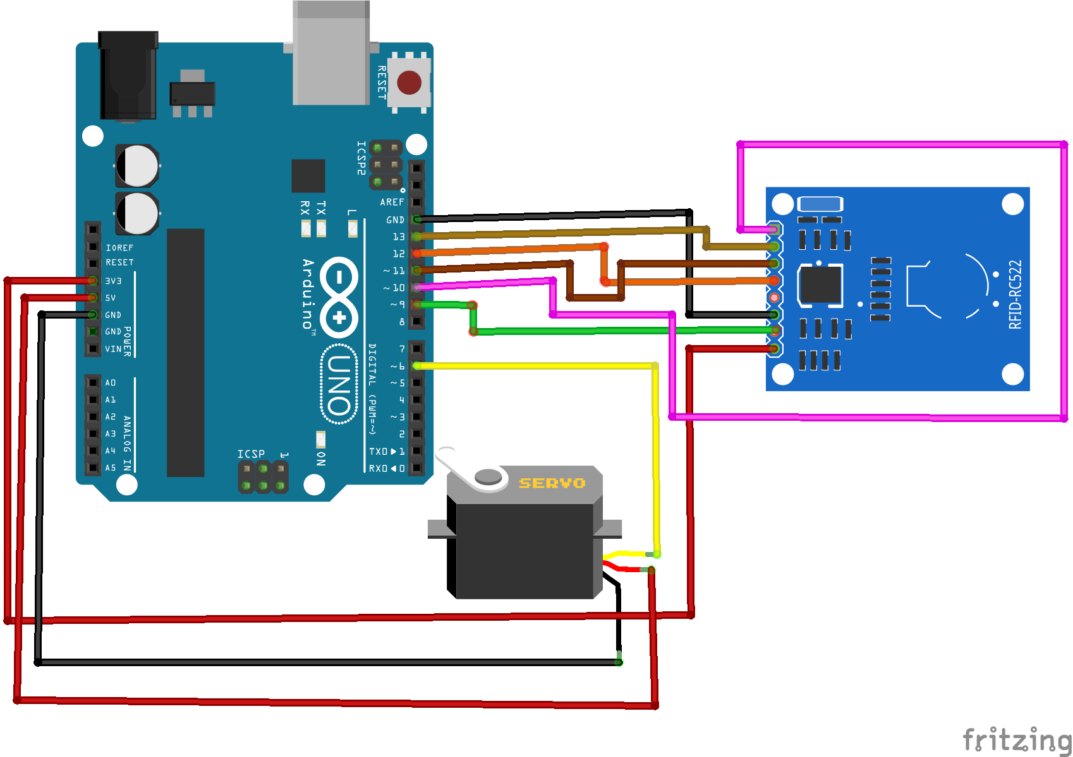

**FUTURE SCOPE**

**Increased Sustainability and Efficiency:**

RFID technology has come a long way in recent years and is already crucial in manufacturing, retail, and healthcare.

Advantages:

**Efficiency:** RFID solutions improve inventory management, reduce losses, and enhance supply chain visibility.

Environmental Impact: By minimizing waste and optimizing processes, RFID contributes to sustainability.

**Considerations:**

Battery-Free Tags: Research is ongoing to develop battery-free RFID tags that harvest energy from ambient sources (like radio waves or light). These tags could further enhance sustainability.

**Flexible Printing Options:**

Thinner and more flexible RFID tags are on the horizon.

**Thin-Film Transistor Technology:** These tags can be mounted on various surfaces, including curved or irregular ones.

**Applications:**

Wearable Tech: Flexible RFID tags could be integrated into clothing, accessories, or even medical devices.

**Smart Packaging:** Imagine RFID-enabled packaging that adapts to product shapes and materials.

Integrations with Other Technologies:

The very structure of today’s RFID tags makes them uniquely versatile, but exciting new integrations take this to the next level.

Already, warehouse management systems (WMS) based on RFID improve traceability and precision for everything from picking to delivery.

**CONCLUSION**

In conclusion:

RFID technology has made significant strides across various industries, revolutionizing how we track and manage objects. Its adoption continues to grow due to efficiency gains and accuracy improvements. RFID enhances supply chain visibility, reduces manual errors, and ensures timely deliveries. As we look ahead, flexible tags, edge computing, and seamless integration with other technologies will shape RFID's future. However, privacy and security challenges remain, requiring a delicate balance between convenience and data protection. Overall, RFID's journey is far from over, and its impact will only expand as we explore new applications and address emerging concerns.

**REFERENCES**

*https://github.com/Vashista27/Vashista*

**THANK YOU TO FICE**